Client / Owner: | Losani Homes (1998) Ltd. (Losani)
Contractor: | Melloul-Blamey Construction Inc. (MB), Pollard Enterprises Ltd. (PE)
Materials: | Elastophene base sheet membrane by Soprema, Type III Grade 1 Asphalt by Bitumar, TREMprime LV primer by Tremco, Elastocol Stick Primer by Soprema, Sopraflash Flam Stick base flashing membrane by Soprema, Elastophene 180 base membrane by Soprema, Sopralene Flam 250 cap membrane by Soprema, Sopradrain 10-G drainage mat by Soprema, Sopra-XPS 35 insulation by Soprema

Pretium was on site to review work in progress and completed to date. Installations were reviewed for compliance with provided construction and shop drawings, manufacturer written specifications, good building practice and Ownership standards. Where project specifications and drawings are insufficient, the manufacturer written specifications, generic details and application instructions will be the minimum standard for the installation. The Design Authority i.e. Architect, and 3rd Party Engineering Consultants should review all reports and advise of any issues or discrepancies with our findings or recommendations. Only items visible at the time of the site visit and at locations outlined below have been reviewed. The following was observed / discussed:
Observations / Comment
- Roofing – Building B
  - New cap membrane flashings are complete throughout (Photograph P1). Cap membrane flashings were measured extending 8” onto the field of the roof (Photograph P2).
  - Installation of new overburden is almost complete throughout (Photograph P3) and was in progress at west end of roof at time of visit. Foreman anticipates installation of overburden will be complete by end of day. The following was observed:
    - New Sopradrain 10G drainage mat is being loose laid directly over top of the completed membrane (Photograph P4).
    - Two layers of Sopra XPS 35 insulation are being loose laid over top of the drainage mat (Photograph P5). The approved assembly lists two layers of 3.5” insulation. A layer of 4” and layer of 3” insulation are being installed. It is Pretium’s opinion this meets the intent of the design. End joints in the same layer were measured offset a minimum of 12” (Photograph P6). End joints between layers were measured offset a minimum 24” (Photograph P7).
    - Filter fabric/geotextile is being loose laid over top of the insulation prior to installation of river stone ballast (Photograph P8). Pretium could not identify the material being installed as no packaging or labels were visible.
  - Drains have been temporarily covered to prevent stone ballast from washing into and blocking the associated plumbing (Photograph P9).
  - Alsan Flashing (liquid applied membrane) is yet to be installed at HSS column details (Photograph P10).
Subsequent to visit, Pollard confirmed that installation of Alsan Flashing is complete at HSS column details (Photograph P11).

- Roofing – Building A
  - The surface of the concrete deck was reviewed, including the location of the recent adhesion tests (Photograph P12). Elastocol Stick primer by Soprema and TREMprime LV primer by Tremco were observed at the adhesion test site.
    - Laitance was observed on the membrane used in the adhesion test (Photograph P13), indicating that the laitance separating from the deck is at least one mode of failure during the adhesion test.
  - The current surface profile of the concrete deck is inconsistent with multiple significant smooth areas observed (Photographs P14-P16).
  - It is understood Soprema will issue the warranty for the approved system at this location BUT if unsuitable substrate surface/inadequate surface preparation is determined to be the cause of a future failure, the warranty may be voided. Based on this it is our recommendation that the deck be shot blast to remove the laitance and provide a consistent surface profile throughout.

 | 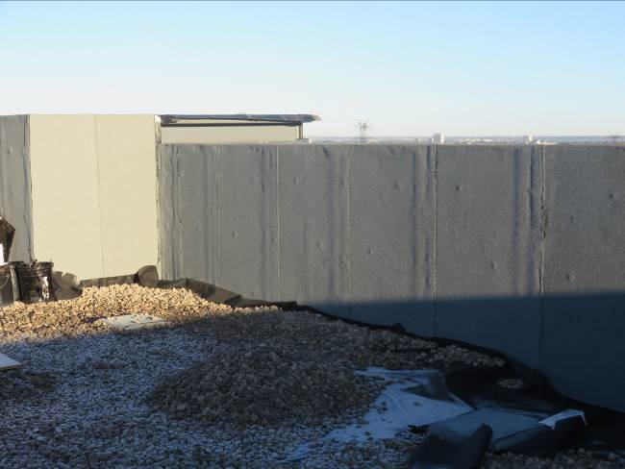 | 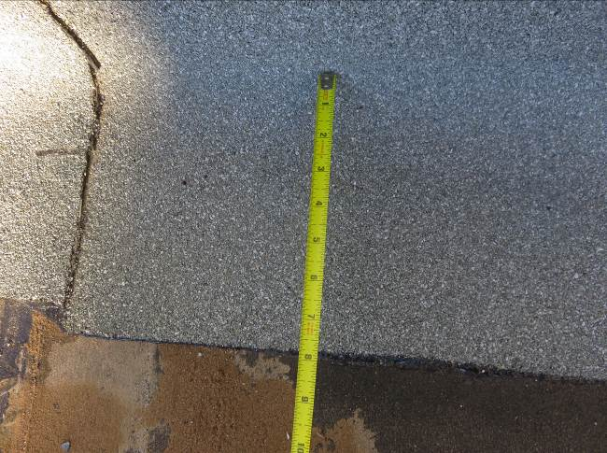
 | - New cap membrane flashings at high parapet detail. (Typ.) | - Cap membrane flashing measured extending 8” onto the field of the roof.
 | 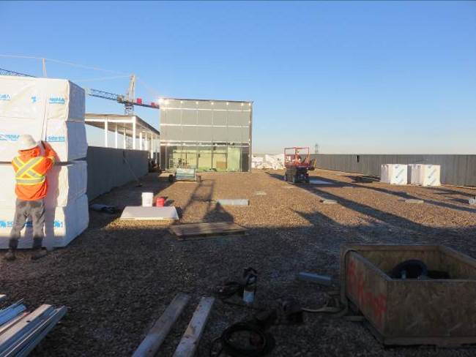 | 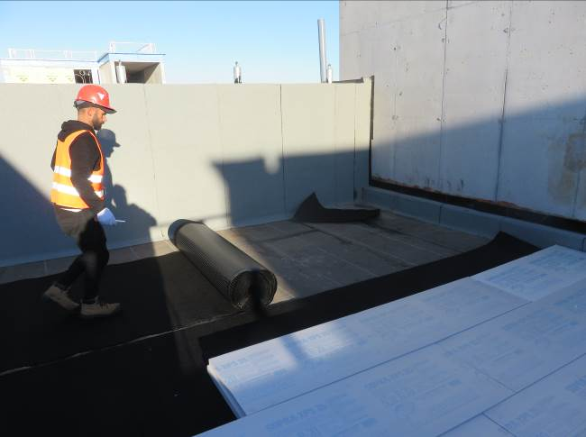
 | - Overview of roof with new overburden in place taken from east end of roof looking west | - Installation of drainage mat directly over membrane. (Typ.)
 | 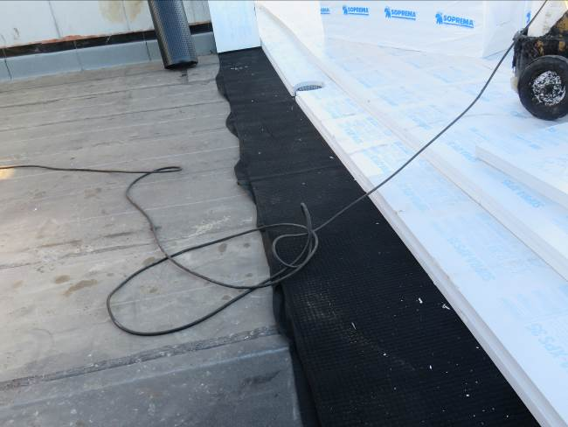 | 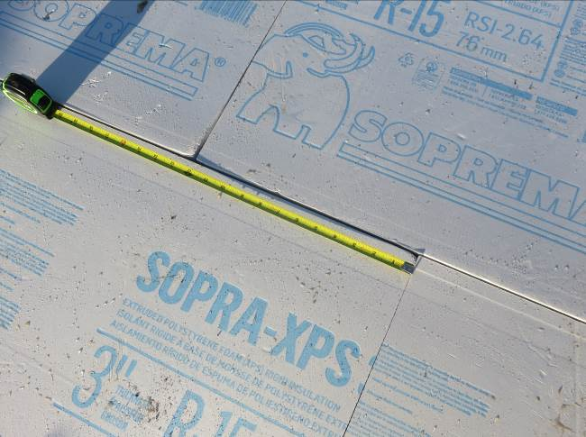
 | - Two layers of XPS insulation totaling 7” directly over top of drainage mat. | - End joints in same layer of insulation measured offset minimum of 12”.
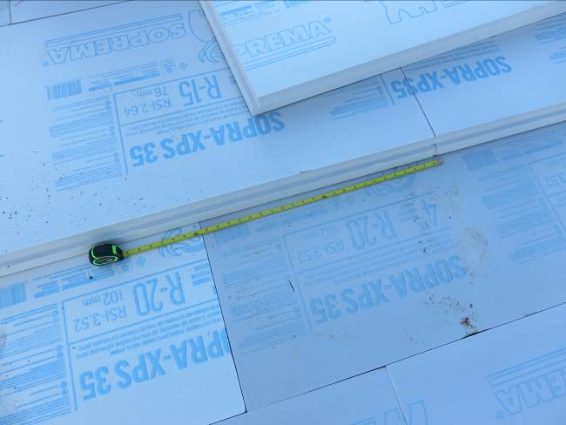 |  | 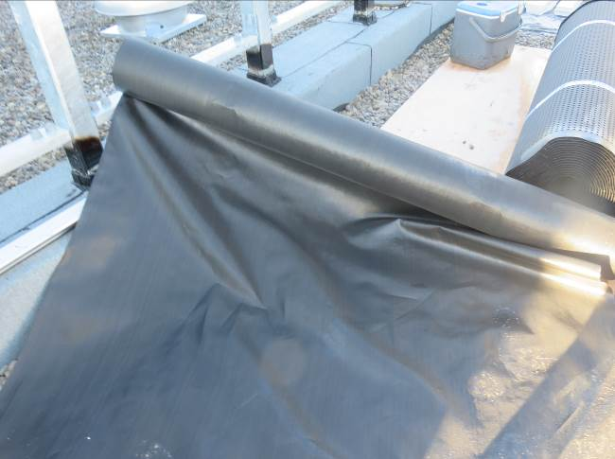
- End joints between layers of insulation measured offset minimum 24”. |  | - Unidentified filter fabric/geotextile.
 | 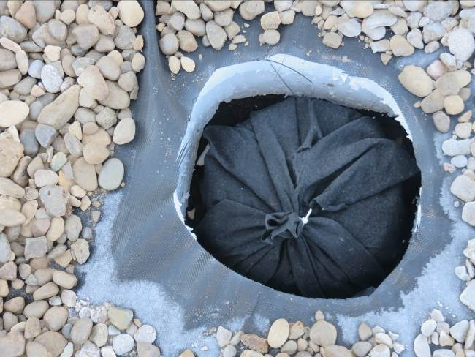 | 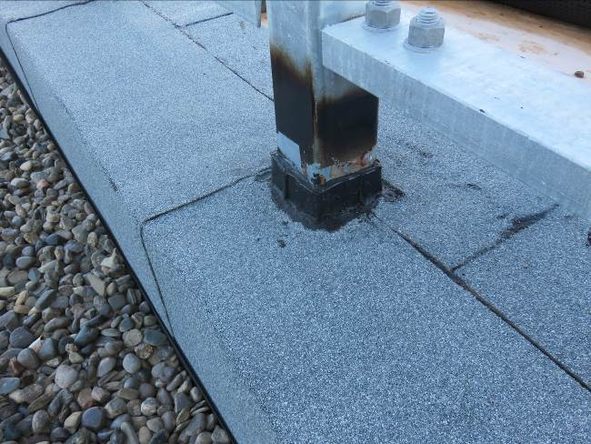
 | - Drains have been temporarily covered. (Typ.) | - Alsan Flashing is yet to be installed at HSS column detail. (Typ.)
 | 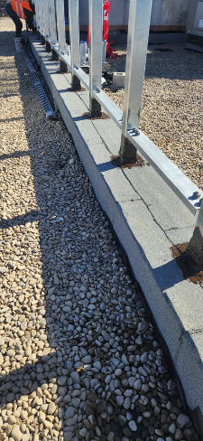 | 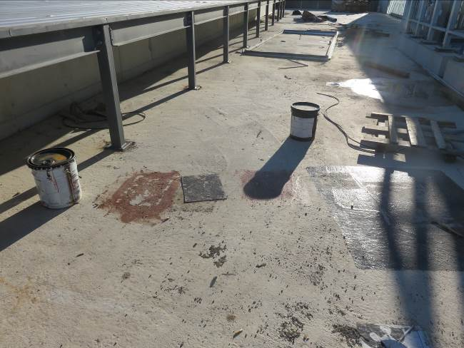
- Completed Alsan Flashing at HSS column details. (Photograph provided by Pollard) |  | - Membrane adhesion test site on Building A.
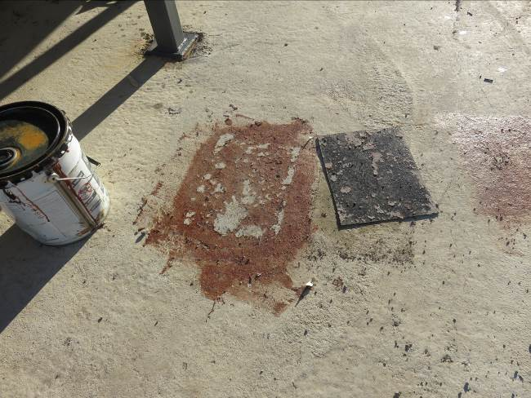 |  | 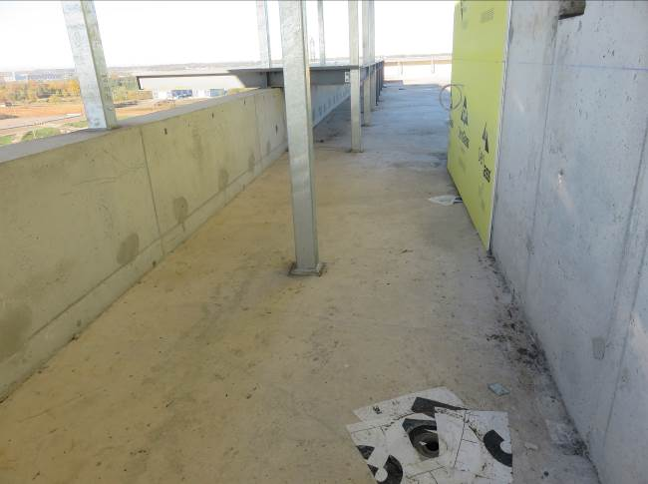
- Laitance is present on the membrane used during the adhesion test. |  | - Area of concrete deck with smooth surface profile. (Typ.)
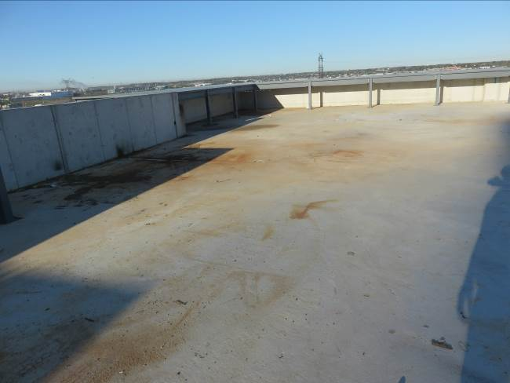 |  | 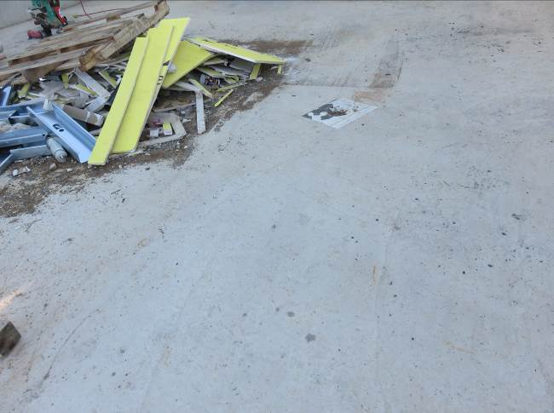
- Area of concrete deck with smooth surface profile. (Typ.) |  | - Area of concrete deck with smooth surface profile. (Typ.)

This report was issued to all parties on November 7, 2026. The deficiency list has been uploaded to Procore.
Trade foreman was verbally notified of report contents. This report pertains to work specifically requested and comments only on operations and items that were visible or being undertaken at the time of our inspection.
Report by: | Dave Neal, RRO | Reviewed by:

